Winter 03| Events

Events and handlers are the actions that you can attach to, for instance, a button. Most of them have been discussed in class. In this class we do an assignment together, in which most of the events will occur again. This is a kind of repetition of the entire period, with almost all of the subject matter.

Step 1: Wireframe
Below a figure which will also appear in class.
screen 1

first name
family name
password

screen 2
Welcome firstname familyname
Select here the region for which you would like to work

screen 3’
‘regionselected’
Here you get a text about this great province, where you can do all kinds of things, introduction to the projects, etc.
--Select—

screen 4
Firstname, do you want to know more about the project? ‘projectselected’ in ‘regionselected’. Now choose the colour you like best.
screen 5
You want to go to Chile. What could your contribution be?
Colour is the same as colourselected
Picture is the same as ‘pictureselected’.
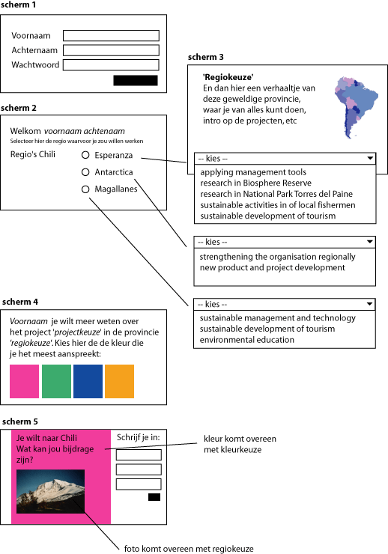

Step 2: Analysis
You will be making a selection program. This is the structure we are going to use. Now we will discuss per screen which elements the screen contains and what kind of script elements we need. For this purpose we use the same scheme, but you will be writing it down on paper in a simpler way. .
What you are doing now is making semi-scripts, also called pseudo-code. If you cannot solve the problem, it is wise to describe your program first in pseudo-code. This will help you to realize a product. In the assessment, if you have not succeeded, I want to see at least such a product.

step 3: Creating the page structure by yourself
Now that it is clear what we are going to make and how we are going to approach it, the computer can be switched on. Make all pages in Flash. Make sure that each page is in its own frame. Use labels to name each framer. I use the names of the screens in the flowchart. You do not have to get your scripts to work yet, but if you think you can do it, do it!
If this is no problem and you are reasonably acquainted with ActionScript, make it a bit harder for yourself by adding the colour to the figures by means of script. In ActionScript there a colour object which you can use. Go to Help to find it. Another interesting thing could be using checkboxes instead of buttons to select the colour.

Step 4: Realizing each screen in class
Screen 1:
Information on the use of text fields. Here you use a static field two times and two input fields. You can give the fields a border which is functional at the input.
Screen 2:
Now we want to find the status of the radio button: checked or not? Place onClickHandler on the radio button, so that click through immediately to the following screen.
Screen 3
Here you find a dropdown box in which various projects can be chosen from. When you make the choice, you go to the next screen immediately. So you have to use the onChange handler. Here it is important to leave the first one empty, because otherwise it could be that there is no change at all.
Screen 4:
This screen has 4 buttons, each with its own colour. When you click on a button, the variable ‘colour’ gets the value “red” or “blue”, depending on the colour of the button. You may prefer to go to the next screen immediately after you have selected the colour, but you can also use a button again.
Screen 5:
Make two movieclips. In the movieclip the field that changes colour is a movieclip itself. When you open the movieclip, you make a frame for every colour that you need. Give each frame a label with the name of the colour. Make sure that the names are the same as the names you have used a values for the variables in screen 4. Give each movieclip an instancename. Now you can refer to them.

Author: Roos Groenewegen
Season: Winter
Lesson number: 03
Date: 13-12-2005
Type of lesson: MME

